Designing and Building Software

Project 3 – Hello, World!

November 7, 2018

Notes

1. Create a new Windows Forms application (See project 2)
2. Title the new form "Hello, World!"
3. Populate the form with
   1. a label
      1. Position the label where you want it
      2. set the label's Text property to *Greeting*
      3. set the label's Name property to m_lblGreeting
   2. a text box
      1. set the text box Name property to m_tbGreeting
      2. Align text box with the Label by dragging it with the mouse
      3. Set text box width as appropriate
   3. a button
      1. set the button's Name property to m_btnSayHelloWorld
      2. Position the button as you wish
      3. set the button's Text property to *Say "Hello, World!"*
4. Run the application and show that the button doesn't do anything.
5. Add the button click event handler by double clicking on the button in the designer view of the form.
6. Type green code shown below into the event handler:  
     
   private void m_btnSayHelloWorld_Click(object sender, EventArgs e)  
   {  
    m_tbGreeting.Text = "Hello, World!";  
   }
7. Run the application by pressing the start button in the main toolbar at the top of the application. 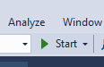
8. You'll see this somewhere on the screen:  
     
   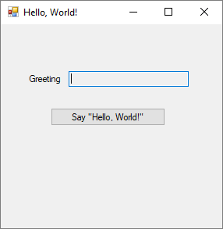
9. Press the Say "Hello, World" button.  
     
   You'll see this:  
     
   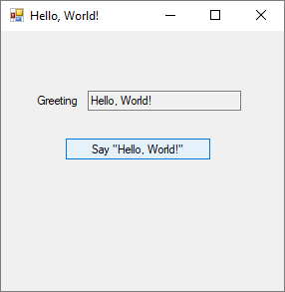
10. Brief Video Explanation of how this works.
11. Watch the video for some remarks about improving this.
    1. Centering on screen
    2. Making the Greeting text box read only so the user can't enter data in it.
    3. Create a new button to clear the greeting.
    4. Create a button to close the form.